|  |  |  |  |  |
| --- | --- | --- | --- | --- |
|  |  | PROJECT REPORT | | |
|  |  | “GET-PC” | | |
|  |  | Submitted by | | |
|  |  | 1. Aum Radia- (186270307523) 2. Darshan Thanki- (186270307060) 3. Raj Mandaviya- (186270307045) 4. Nilay Joshi- (186270307030) | | |
|  | | In partial fulfillment for the award of the degree | | |
|  | |  | Of |
|  | |  | DIPLOMA OF ENGINEERING |
|  | |  | In |
|  | |  | Department of Computer Engineering |
|  | |  | Government Polytechnic Porbandar |
|  | |  |  |
|  | |  |  |

|  |  |  |
| --- | --- | --- |
| http://itmuniverse.ac.in/wp-content/uploads/easy_logo_slider/968109gtulogo-452x312.jpg |  |  |
|  |  |  |

**A**ffiliated to Gujarat Technological University, Chandkheda, Ahmedabad

Academic Year: 2020-21

|  |  |  |
| --- | --- | --- |
| http://itmuniverse.ac.in/wp-content/uploads/easy_logo_slider/968109gtulogo-452x312.jpg |  |  |
|  |  |  |

*Government polytechnic Porbandar*

*COLLEGE ADDRESS*

*Opp. Airport, NH-27, Chhaya, Porbandar*

DECLARATION

We hereby declare that the Reports, submitted along with the Project Report for the project entitled “_______GET-PC______” submitted in partial fulfillment for the degree of Diploma of Engineering inComputer to Gujarat Technological University,Ahmedabad, is a bonafide record of the project work carried out at ___GPPorbandar under thesupervision of Mehul Gundaliya and that no part of any of these reports has been directly copied from any students’ reports or taken from any other source, without providing due reference.



Name of The Students Sign of Students

1. Aum Radia
2. Darshan Thanki
3. Raj Mandaviya

4. Nilay Joshi

|  |  |  |
| --- | --- | --- |
| http://itmuniverse.ac.in/wp-content/uploads/easy_logo_slider/968109gtulogo-452x312.jpg |  |  |
|  |  |  |

***Government polytechnic Porbandar***

***COLLEGE ADDRESS***

***Opp. Airport, NH-27, Chhaya, Porbandar***

CERTIFICATE

This is to certify that the reports, submitted along with the project entitled***__*GET-PC_____** has been carried out by**_Aum Radia,Darshan Thanki,Raj Mandaviya,Nilay Joshi*____***under my guidance in partial fulfillment for the degree of: **Diploma of Engineering** in **Computer*_*5thSemester** of Gujarat Technological University, Ahmadabad during the academic year 2020-21. These students have successfully completed report activity under my guidance.

**Internal GuideHead of the Department**

**ACKNOWLEDGEMENT**

I am grateful to **Prof. Manilal B. Kalariya,**Head of Department, department of computer engineering for providing me all the facility that was required for the successfully completion of our project.Our special thanks of gratitude to our internal guide**Prof. Mehul Gundaliya** for his valuable guidance and support in completing our project. I would like to thanks to all professors,parents and friends who helped me a lot in finalizing this project within the limited time frame. Last but not the least we are grateful to authors of the reference and other literatures referred to in this project.

**Name of Student**

**Aum Radia**

**Darshan Thanki**

**Raj Mandaviya**

**Nilay Joshi**

**Index**

|  |  |  |
| --- | --- | --- |
| Sr No. | Content | Page No. |
|  | **Chapter:1**   1. **Introduction**    1. Aim and Objective    2. Scope - Modules    3. Overview of website and Advantage    4. Process Model | 6-7 |
|  | **Chapter:2**   1. **System Requirements Specification**    1. User Characteristics    2. Functional Requirements    3. Non-Functional Requirements | 8 |
|  | **Chapter:3**   1. **System Analysis Modeling – User-based**    1. Feasibility Study of the New System – Here you have to discuss the following feasibilities: Technical Feasibility, Time Feasibility, and Cost Feasibility.    2. User-Based Modeling       1. Use Case Diagrams | 9 |
|  | **Chapter:4**   1. **System Analysis and Design – Data-based**    1. Data Modeling       1. Data Dictionary (List of Database Tables included in the system)       2. E-R (Entity-Relationship) Diagram    2. Behavioral Modeling       1. Data Flow Diagram          1. Context Level Diagram (Level 0)          2. DFD – Level 1 | 10-13 |
|  | **Chapter:5**   1. **System Design – UML**    1. Sequence Diagrams    2. Activity Diagrams | 14-16 |
|  | **Chapter:6**   * 1. **Graphical User Interface Design** |  |

Chapter 1: Introductions

* 1. Characteristics of existing system:

In Current System People Needs to visit different shops near them.And then ask them to suggest product and its price, Specs, etc.The Disadvantage is that the shop owner might suggest an over price product or a product in which they can earn more profit.Hence, time and money is wasted.

* 1. Overview of website and advantages:

Proposed system provides an a website that people can use to find best product available.People needs to enter certain detail in return they will get our top suggested picks.Thus, helping them by providing easy to use, easy to understand and user friendly website on which people can find there required product in their convenient time and place.

Advantages:

1. More reliable.
2. Saves Time.
3. Easy to use.

1.3 Scope:

Scope of this project is to build a buying guide webiste for Laptop/Pc.Through this website people can easily find the best product according to their need.They just need to enter certain details and in very short span of time they will find what they wanted.It will allow them to do further sorting and will also allow them to buy the suggested product from the link given if they wanted.

Modules:

Budget:-

User need to select budget in this module

Daily usage:-

User needs to select what is their primary need of a product

Switch :-

It will allow user to switch from laptop to pc and vice versa with same configurations enter previosly

Further sorting:-

User can go with brands as per their choice

About:-

All the information about webiste and how to use webiste will be given here

Contact us:-

User can contact us through this

1.4 Process Model:

* Waterfall model

Requirements:

In this phase all the requirements are gathered.

Design:

In this phase a simple design of database required and design of website is created

Implementation:

After that the implementation is started.In this phase work on the design created in previous phase is started.

Verification:

Then in verification phase it is checked that is fulfill all the requirements and if website works in a proper manner or not.

Maintenance:

After that further some additional functions are added as per need and also some

Chapter 2: System Requirements Specification

2.1 User Characteristics

There only two users dealing with our system.

Admin:-

Admin is person who can edit the website and can also edit the database

End user:-

This person can only use the functionalities provided to them

* 1. Functional Requirements

Budget:-

User can select the a amount they are willing to pay for product

Daily usage:-

User can select their primary usage of a product

Laptop/PC:-

User need to select either they are looking for a laptop or a pc

Further sorting:-

User can perform sorting on the returned datbbase

Switch:-

User can switch the product if they want

* 1. Non-Functional Requirements

About:-

Here user can read all the information about about our webiste and

Contact us:-

User can contact us if they want to report a problem or have a suggestion

Chapter 3: System Analysis Modeling – User-based

3.1 Feasibility Study of the New System

Technical Feasibility:-

This project is technically feasible to run in any system as it does not require any enhanced requirement to run it.

Time Feasibility:-

It will take approximately 5 to 6 months time to complete this project.

Cost Feasibility:-

This project is made for education purpose so it does not cost anything execpt time.

3.2 User-Based Modeling

3.2.1 Use Case Diagram

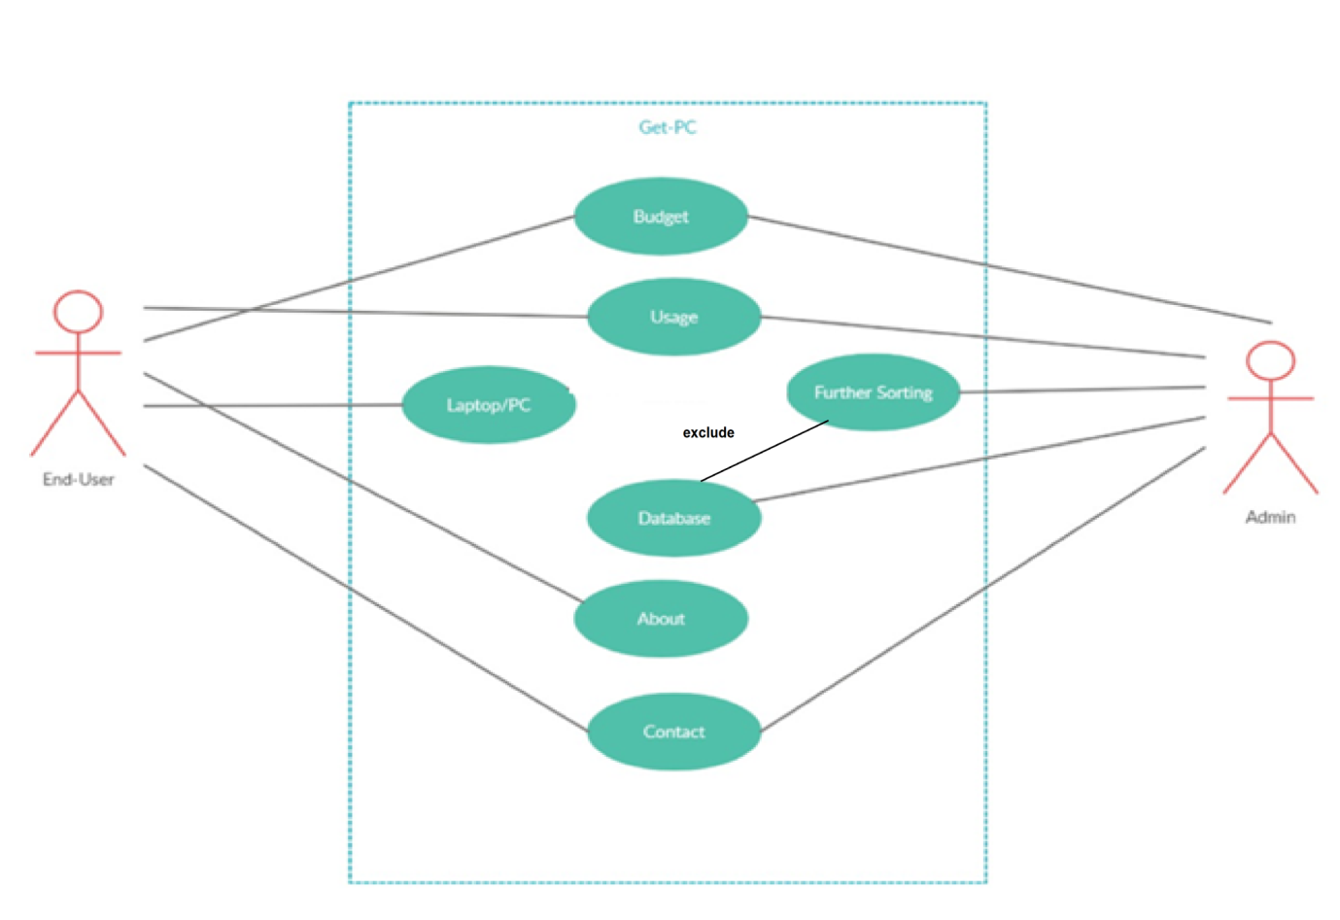

Chapter 4: System Analysis and Design – Data-based

4.1Data Modeling

4.1.2Data Dictionary:

LAPTOP

|  |  |  |
| --- | --- | --- |
| Collumn Name | Data type | Size |
| IMG | BLOB | ____________________________ |
| NAME | VARCHAR | 40 |
| PROCESSOR | VARCHAR | 20 |
| GRAPHIC CARD | VARCHAR | 20 |
| RAM | VARCHAR | 10 |
| STORAGE | VARCHAR | 30 |
| USAGE | VARCHAR | 10 |
| PRICE | VARCHAR | 10 |
| LINK | VARCHAR | ____________________ |

|  |  |  |  |  |  |  |  |  |
| --- | --- | --- | --- | --- | --- | --- | --- | --- |
| IMG | NAME | PROCESSOR | GRAPHIC CARD | RAM | STORAGE | USAGE | PRICE | LINK |
|  |  |  |  |  |  |  |  |  |
|  |  |  |  |  |  |  |  |  |

PC

|  |  |  |
| --- | --- | --- |
| Collumn Name | Data type | Size |
| IMG | BLOB | ____________________________ |
| NAME | VARCHAR | 40 |
| PROCESSOR | VARCHAR | 20 |
| GRAPHIC CARD | VARCHAR | 20 |
| RAM | VARCHAR | 10 |
| STORAGE | VARCHAR | 30 |
| MOTHERBOARD | VARCHAR | 20 |
| COOLER | VARCHAR | 20 |
| CABINET | VARCHAR | 20 |
| POWER SUPPPLY | VARCGAR | 20 |
| USAGE | VARCHAR | 10 |
| PRICE | VARCHAR | 10 |
| LINK | VARCHAR | ____________________ |

|  |  |  |  |  |  |  |  |  |  |  |  |  |
| --- | --- | --- | --- | --- | --- | --- | --- | --- | --- | --- | --- | --- |
| **COOLER** | **IMG** | **NAME** | **PROCESSOR** | **GRAPHIC CARD** | **RAM** | **STORAGE** | **CABINET** | **USAGE** | **PRICE** | **LINK** | **POWER SUPPLY** | **MOTHERBOARD** |
|  |  |  |  |  |  |  |  |  |  |  |  |  |
|  |  |  |  |  |  |  |  |  |  |  |  |  |
|  |  |  |  |  |  |  |  |  |  |  |  |  |

4.1.2 E-R Diagram:



4.2 Behavioral Modeling

**4.2.1 Data Flow Diagram**

4.2.1.1 Context Level Diagram (Level 0)

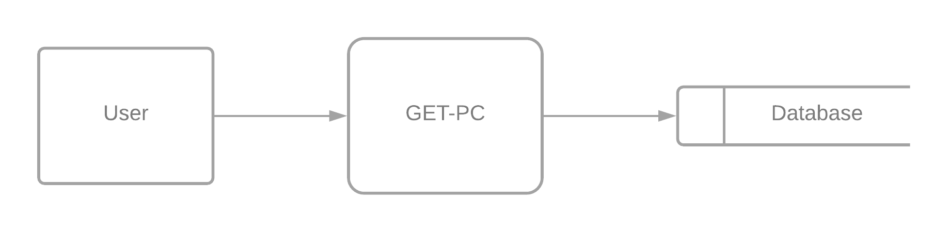

4.2.1.2 DFD – Level 1

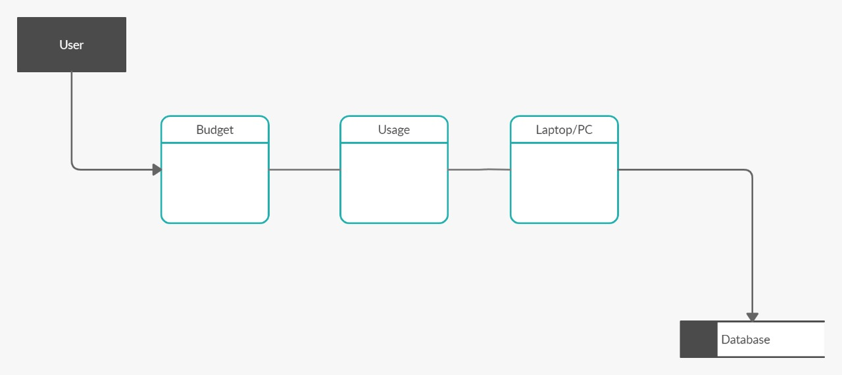

4.2.1.3 DFD LEVEL 2

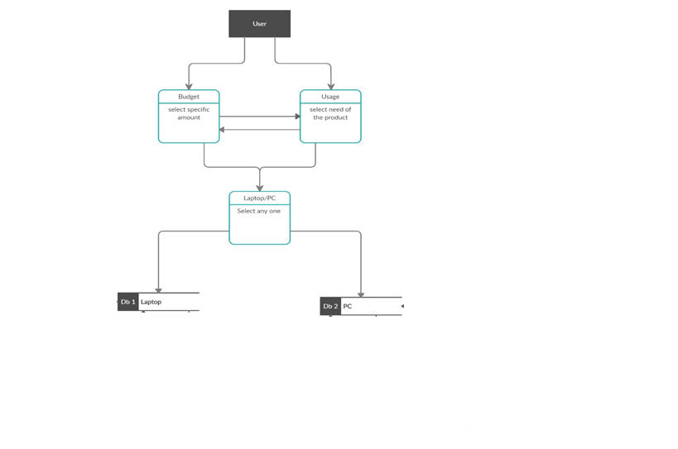

Chapter 5: System Design – UML

5.1 Sequence Diagram

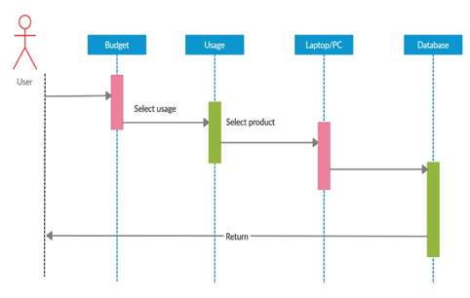

5.2 Activity Diagram

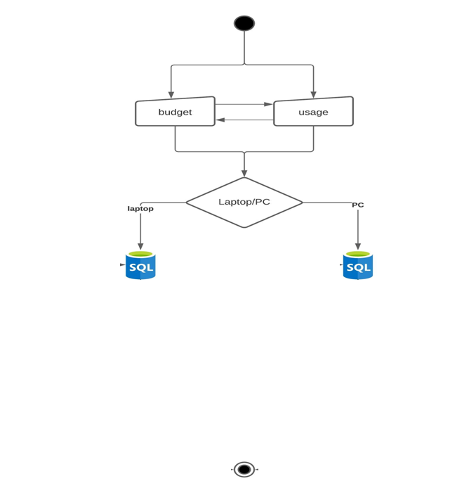

Laptop

PC

6.0 System Interface Design

6.1 Graphical User Interface Design



